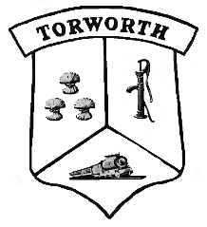  I  1  2  3  4  5  6  7  8  9  10 | TORWORTH  PARISH  COUNCIL  NOTICE OF ANNUAL PARISH OPEN MEETING  FOR TORWORTH  NOTICE IS HEREBY GIVEN THAT  The Annual Assembly of the Parish Meeting for Torworth will be held at Torworth Grange Café on Tuesday, June 4th, 2019 at 7pm.  This is not to be confused with the Annual Parish Council Meeting but an open meeting of the Parish. The Parish Council traditionally facilitates the meeting and creates a running order to include current matters known to be of interest to the community. However, any relevant matters can be raised for discussion at the meeting by any member of the Parish.  The business to be transacted at the meeting will be as follows:  Chairman’s Welcome  Apologies  Minutes of the last Annual Parish Meeting  Chairman’s 2017-18 Report  Annual report by County Councillor Tracey Taylor  Annual report by District Councillor Michael Gray  Report on the 2017-18 financial year  Report from local groups  Any other business  Discussion and general questions will follow

MEETING of TORWORTH PARISH COUNCIL

I hereby give you notice that a meeting of Torworth Parish Council will be held at 7:00pm on Tuesday, May 1st, 2018 at Torworth Grange Café. All members of the Council are summoned to attend for the purpose of considering and resolving upon matters set out hereunder.

Dated this 22nd of April 2018

Claire Challener
Clerk of Torworth Parish Council

